YEAR 11 ATAR Course Examination
Question/Answer Booklet

ECONOMICS Units 1 & 2

Semester 2 2018

Student number:

Time allowed for this paper
Reading time before commencing work: ten minutes
Working time for paper: three hours

Materials required/recommended for this paper
To be provided by the supervisor
This Question/Answer Booklet
Multiple-choice Answer Sheet
Two separate booklets for your extended answers

To be provided by the candidate
Standard items: pens (blue/black preferred), pencils (including coloured), sharpener,
correction fluid/tape, eraser, ruler, highlighters
Special items: non-programmable calculators approved for use in the WACE examinations

Important note to candidates
No other items may be taken into the examination room. It is your responsibility to ensure that you do not have any unauthorised material. If you have any unauthorised material with you, hand it to the supervisor before reading any further.

Structure of this paper

Section | Number of questions available | Number of questions to be answered | Suggested working time (minutes) | Marks available | Percentage of examination
Section One  Multiple-choice | 24 | 24 | 30 | 24 | 24
Section Two  Data interpretation / Short answer | 3 | 3 | 70 | 36 | 36
Section Three  Extended answer | 4 | 2 | 80 | 40 | 40
 |  |  |  | Total | 100

Instructions to candidates

1. Answer the questions according to the following instructions.

Section One: Answer all questions on the separate Multiple-choice answer sheet provided. For each question, either place a cross over the correct answer or shade in the correct answer. Use only a blue or black pen. If you make a mistake, place a cross through that square, then select your new answer. Do not erase or use correction fluid/tape. Marks will not be deducted for incorrect answers. No marks will be given if more than one answer is completed for any question.

Sections Two: Write your answers in this Question/Answer Booklet.
Section Three: Write each answer in a separate booklet.

2. You must be careful to confine your answers to the specific questions asked and to follow any instructions that are specific to a particular question.

3. Supplementary pages for the use of planning/continuing your answer to a question have been provided at the end of this Question/Answer booklet. If you use these pages to continue an answer, indicate at the original answer where the answer is continued, i.e. give the page number.

See next page

Section 1: Multiple-choice 24% (24 Marks)
This section has 24 questions. Answer all questions on the separate Multiple-choice answer sheet provided. For each question, either place a cross over the correct answer or shade in the correct answer. Use only a blue or black pen to shade the boxes. If you make a mistake, place a cross through that square, then select your new answer. Do not erase or use correction fluid/tape. Marks will not be deducted for incorrect answers. No marks will be given if more than one answer is completed for any question.
Suggested working time: 30 minutes
____________________________________________________________________________

1. The most important feature of a competitive market is that it
(a) must have a physical location.
(b) includes markets for goods and services but not for inputs.
(c) has so many buyers and sellers that no one can influence the price.
(d) has one seller competing to sell his or her product.

2. Suppose over the next several years the productivity of firms producing electric cars improves dramatically. The advance in productivity leads to
(a) a decrease in the supply of electric cars so that the supply curve shifts leftward.
(b) a decrease in the supply of electric cars so that the supply curve shifts rightward.
(c) an increase in the supply of electric cars so that the supply curve shifts leftward.
(d) an increase in the supply electric cars so that the supply curve shifts rightward.

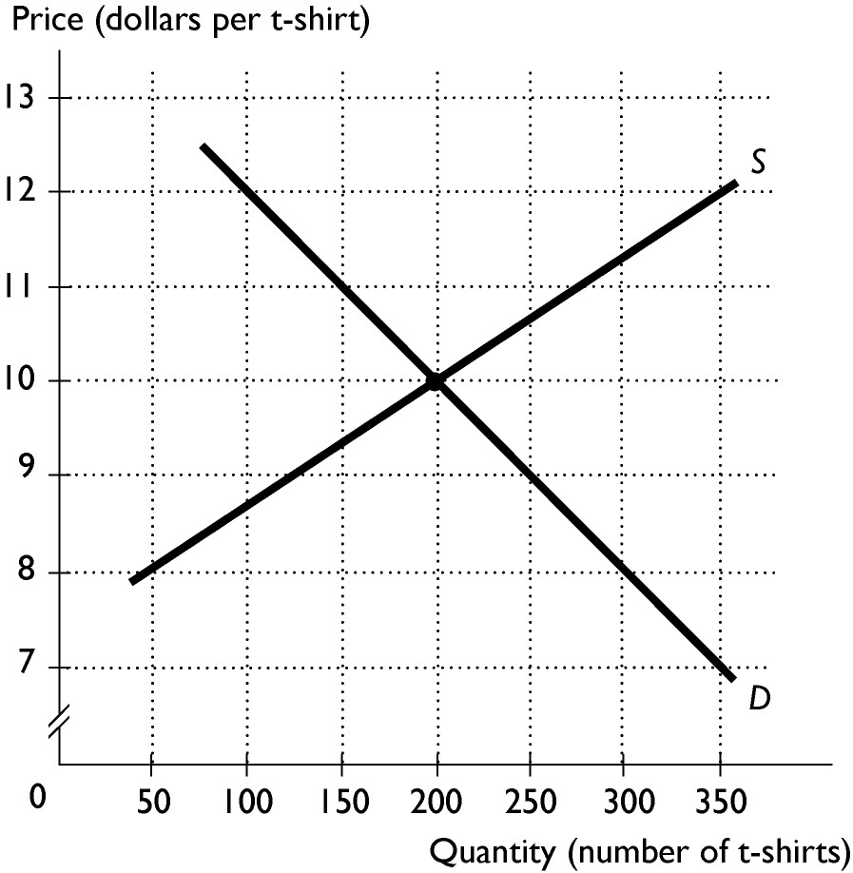
3. The diagram shows the market for t-shirts. If the price of t-shirts is $8, then
(a) there is a shortage and the price of t-shirts will rise.
(b) there is a surplus and the price of t-shirts will rise.
(c) there is a shortage and the price of t-shirts will fall.
(d) there is a surplus and the price of t-shirts will fall.

4. Which of the following statements is correct?
(a) The demand for Nike shoes is more elastic than the demand for shoes in general.
(b) The demand for luxuries is less elastic than the demand for necessities.
(c) The demand for a narrowly defined good is less elastic than the demand for a more broadly defined good.
(d) The larger the proportion of income spent on a good, the smaller the elasticity of demand.

See next page

5. The impact on the market for strawberries of the needle scare has been
(a) a decrease in the demand for strawberries resulting in a fall in prices
(b) a contraction in the demand for strawberries as a result of falling prices
(c) a decrease in the supply of strawberries resulting in an increase in prices
(d) an expansion in the supply of strawberries as a result of falling prices.

6. If a small percentage increase in the price of chocolate causes a larger percentage increase in the quantity supplied, the
(a) supply of chocolate is inelastic.
(b) demand for chocolate is elastic.
(c) supply of chocolate is elastic.
(d) demand for chocolate is inelastic.

7. Andrea said to her friend, "I just bought a new pair of dancing shoes and I love them so much that I totally would have paid more for them." Andrea was describing the concept of
(a) producer surplus.
(b) consumer surplus.
(c) equilibrium.
(d) total surplus.

8. For resource use to be allocatively efficient, when the marginal benefit of a slice of pizza exceeds the marginal cost, ________.
(a) more slices of pizza should be produced
(b) fewer slices of pizza should be produced
(c) no more slices of pizza should be produced
(d) allocative efficiency is reached only if the marginal benefit exceeds the marginal cost by as much as possible

9. Suppose a price floor on wine is proposed by the Health Minister. What will be the likely effect on the market for wine?
(a) Quantity demanded will increase, quantity supplied will decrease, and a surplus will result.
(b) Quantity demanded will decrease, quantity supplied will increase, and a surplus will result.
(c) Quantity demanded will decrease, quantity supplied will increase, and a shortage will result.
(d) Quantity demanded will increase, quantity supplied will decrease, and a shortage will result.

See next page

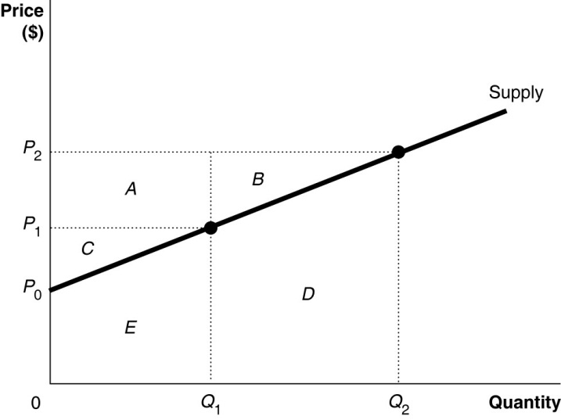
10. Refer to the figure opposite. What area represents producer surplus when the market price is P2?
(a) A + B
(b) A + B + C
(c) D + E
(d) A + B + C – D – E

11. A good that is ________ and ________ is a ________.
(a) rival; nonexcludable; private good
(b) rival; excludable; club good
(c) nonrival; excludable; common resource
(d) nonrival; nonexcludable; public good

12. The deadweight loss associated with producing a product that has an external cost occurs because
(a) too much output is produced.
(b) too little output is produced.
(c) the price firms charge for the good is too high.
(d) not enough resources are allocated to producing the good.

13. Which of the following would be regarded as part of microeconomics?
(a) the unemployment rate
(b) the rate of economic growth
(c) the level of tariffs in the vehicle industry
(d) the level of business confidence

14. Which type of unemployment normally increases during a downswing?
(a) Frictional
(b) Structural
(c) Cyclical
(d) Seasonal

15. Which one of the following is an example of government capital expenditure?
(a) personal income tax refunds
(b) payment of unemployment benefits
(c) government loans to students for university fees
(d) provision of transport infrastructure

See next page
16. Refer to the hypothetical data for an economy below:
G | M | T | I | X | S
25 | 60 | 30 | 20 | 70 | 35

Which statement about this economy is correct?
(a) It is expanding because exports are greater than imports.
(b) It is contracting because savings are greater than taxation.
(c) It is expanding because injections are greater than leakages.
(d) It is contracting because leakages are greater than injections.

17. The rate of growth of real Gross Domestic Product (GDP) per capita might understate the improvement in living standards if
(a) inflation is increasing.
(b) pollution is increasing.
(c) population is increasing.
(d) leisure time is increasing.

18. Which of the following would be considered leading economic indicators?
i. Share prices
ii. Inflation rate
iii. Unemployment rate
iv. Building permits
v. Real GDP
(a) ii and iii
(b) i and iv.
(c) ii and v
(d) iv and v

19. The two largest categories in the CPI are
(a) transport and health
(b) food and entertainment
(c) clothing and food
(d) housing and food

See next page

20. Which one of the following would be recorded as a debit in Australia’s balance of payments on current account?
(a) the sale of Australian wool to Italy
(b) an increase in the number of foreign tourists visiting Australia
(c) interest paid on Australian Government bonds to overseas investors
(d) a Chinese company purchasing a farming property in rural Australia

21. The distribution of income is likely to become more equitable in the Australian economy if the government were to
(a) move from a progressive to a proportional income tax system.
(b) increase the goods and services tax (GST) from 10% to 15%.
(c) increase spending on education and health.
(d) remove the capital gains tax.
22. The diagram opposite shows Lorenz curves for country A and country B. Which of the following statements is correct?
(a) Country A has a less equitable distribution of income than country B.
(b) Country A has a more equitable distribution of income than country B.
(c) The Gini coefficient for country A is equal to 1.
(d) The Gini coefficient for country A is greater than for country B.

23. An example of a progressive tax is _____________ and an example of a regressive tax is ____________ .
(a) excise duty; company tax
(b) company tax; personal income tax
(c) GST; capital gains tax
(d) personal income tax; excise duty

24. Which of the following statements is correct regarding Australia’s economic performance during 2018?
(a) Australia’s growth rate increased and the unemployment rate decreased.
(b) Australia’s growth rate decreased and the inflation rate decreased.
(c) The economy reached a peak in the business cycle.
(d) The economy reached a trough in the business cycle.
_____________________________________________________________________________

End of Section One

See next page

Section Two: Data interpretation/Short answer 36% (36 Marks)

This section contains three (3) questions. Answer all questions. Write your answers in the
spaces provided.
Supplementary pages for the use of planning/continuing your answer to a question have been provided at the end of this Question/Answer booklet. If you use these pages to continue an answer, indicate at the original answer where the answer is continued, i.e. give the page number.
Suggested working time: 70 minutes.
_____________________________________________________________________________

Question 25 (12 marks)

Pain at the Bowser
By John Bamlett dated: 10 Sept 2018

Perth motorists are being forced to pay more at their local petrol stations. Prices have risen to almost $1.60 per litre. They are angry about this and want to know what is causing this spike in prices. To try to get some understanding of the situation I asked Yin Lee, a prominent economist, for an explanation. She said that ‘Petrol is produced from the refining of oil. Petrol prices have risen because of a rise in oil prices following the US’s embargo on Iran and the fact that Cyclone Michael has destroyed oil wells in the Gulf of Mexico’.
- i) Provide one reason from the text for the rise in the oil price
(1 mark)

- Suggest one possible effects the rise in petrol prices mentioned in the article could have on consumer behaviour. (1 mark)

- Explain the relationship between petrol prices and oil prices. (4 marks)

- Using a diagram, explain how the price mechanism should work to clear the shortage in the oil market following Cyclone Michael. (6 marks)

Question 26 (12 marks)
Energy Markets was too Concentrated

The Grattan Institute's Tony Wood said there was no doubt Australia's energy market was too concentrated. The ACCC found this concentration resulted in a lack of competition, which has kept power prices high.

"In this case, I think the ACCC is absolutely right," Mr Wood, the think tank's energy program director, said. "Some of that has happened through past mergers and acquisitions, some through government ownership and some through plants closing down and leaving the existing ones with a high market power."

A lack of competition and policy mistakes have added significant costs to power bills, the ACCC said. ACCC chairman Rod Sims has recommended changes to the way people are charged for power, saying retailers have made the price structures confusing and difficult to compare.

Source: Adapted from: http://www.abc.net.au/news/2018-07-11/power-bills-can-be-cut-if-competition-boosted-accc-says/9978690

- Define the term ‘market power’. (1 mark)

- With reference to the article, identify two ways market power can be accumulated. (2 marks)

See next page

- Using a diagram, explain why there is market failure in the energy market.
(4 marks)

- Explain the role of the ACCC and discuss how the government can intervene in the energy market. (5 marks)

Question 27 (12 marks)
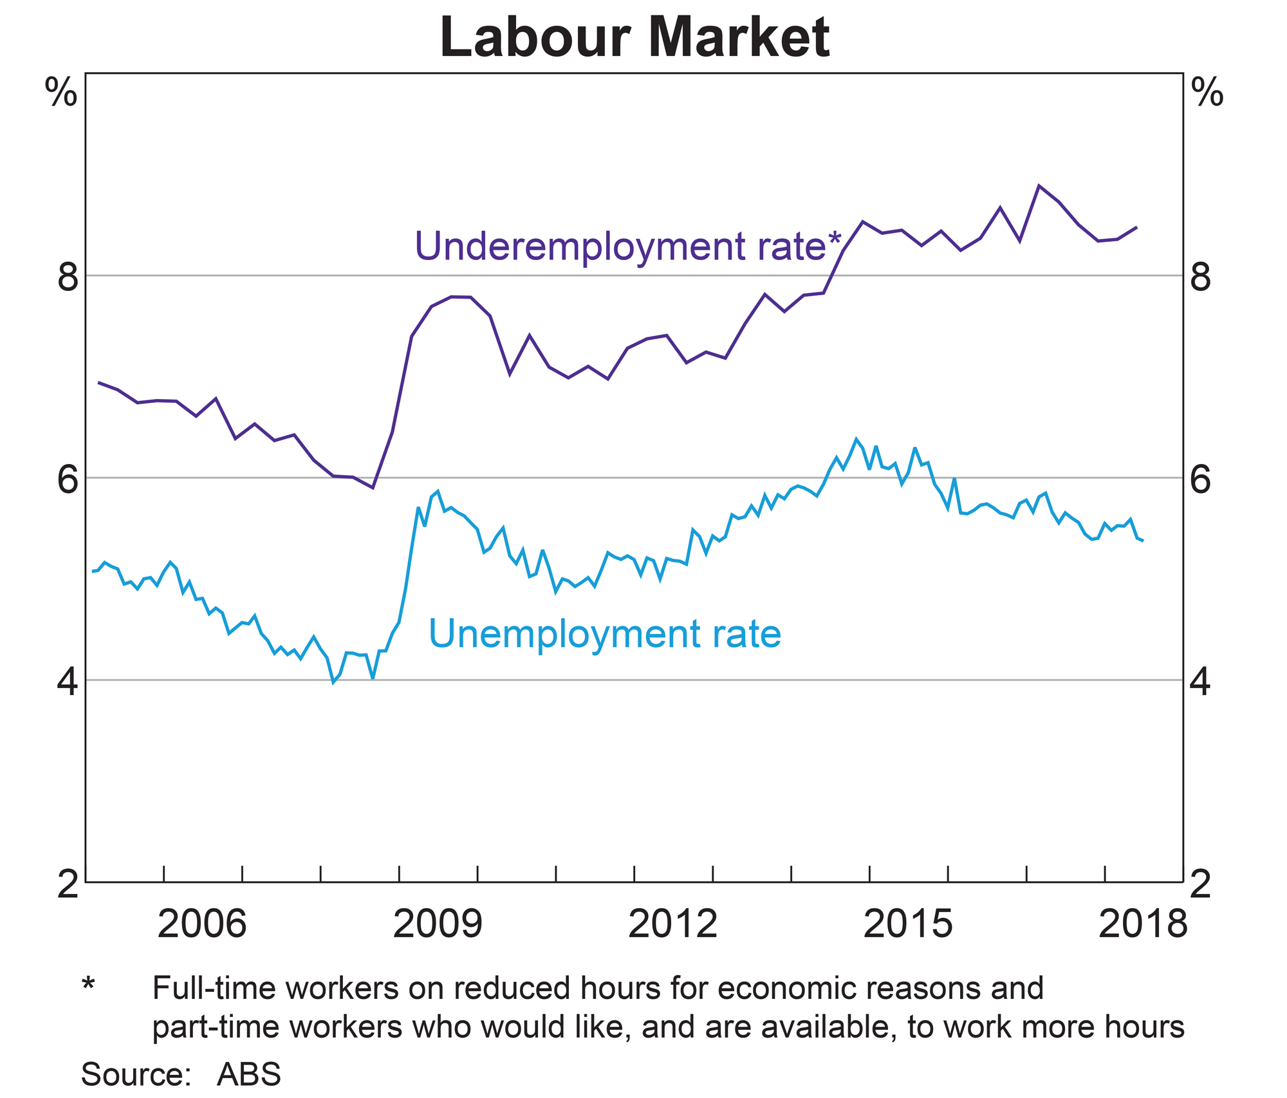
Source: RBA

- i) State the percentage change in the unemployment rate between 2015-18. (1 mark)

ii) Using the graph, describe what has occurred to cyclical unemployment during 2015 – 2018. (1 mark)

- Describe how the government uses taxation and government spending to reduce income inequality. (4 marks)

- Using examples, describe the three main types of unemployment. (6 marks)

End of Section Two

See next page

Section Three: Extended answer 40% (40 Marks)

This section contains four (4) questions. Answer two (2) questions. Write your answers in the separate booklets provided and number your answers clearly.
Suggested working time: 80 minutes.
_____________________________________________________________________________

Question 28 (20 marks)

a. Using examples, explain the Law of Demand and the Law of Supply. (8 marks)

b. Explain reasons for implementing price controls. Using appropriate diagrams, explain the effects of price controls in a market. (12 marks)
_____________________________________________________________________________

Question 29 (20 marks)

(a) Explain four factors that affect Price Elasticity of Demand (PED). (8 marks)

(b) Explain why firms and government are interested in Price Elasticity of Demand, Income Elasticity of Demand, and Cross Elasticity of Demand.
(12 marks)
_____________________________________________________________________________

Question 30 (20 marks)

(a) Using examples, explain how the composition and direction of trade has changed in Australia in recent times. (8 marks)

(b) Describe the general structure of the Balance of Payments account. (12 marks)
_____________________________________________________________________________

Question 31 (20 marks)

(a) Draw a diagram of the business cycle and describe the characteristics of each phase. (8 marks)

(b) Outline the four components of aggregate expenditure and describe the effects on each component during a business cycle downswing. (12 marks)
_____________________________________________________________________________

End of questions

